Personal Information
- Name: Mai Chi Nghi
- Student Number: s3864219
- E-mail: s3864219@rmit.edu.vn
I am living in Binh Duong, Vietnam, and I graduated from my 12 years of school 2 years ago so that I can communicate with everyone in two languages: Vietnamese and English. I started to study at RMIT University in 2019. I am studying an English course to get a Bachelor of Information Technology for now. Besides that, I already joined the Flag Football Club (FFC) as a member at university and when I have free time I play games, along with going to coffee shops with my friends.

Ideal job
- My ideal job is as a security engineer. Including the link below: https://itviec.com/ (Seek, 2021).

- The role of this position is that people have to do teamwork and have the responsibility, highly concentrated, that helps us manage time better and work more flexibly when working together.
- The security engineer requires:
- High concentrate
- Be carefully
- Following step by step
- From my current experience, qualifications and skills are ca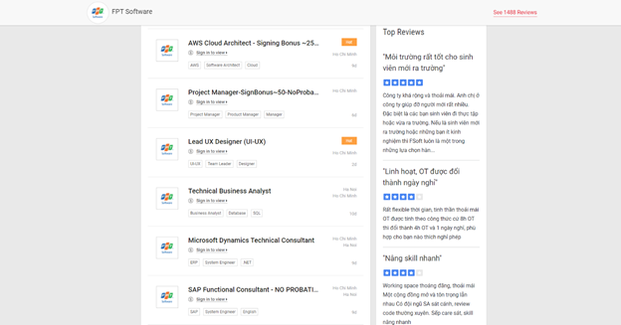reful at work when I work on the team by checking after each step that my teammate did the deadline, which takes me 3 years or more. This knowledge will help us fix many problems, which we have to confront during group work. Due diligence makes it possible for me to see each member’s issue in the team, then each person has to give suggestions on the solution and explain why they have those issues to learn from and improve their skills to work better in the future.
- My plan to obtain this position, that I need to learn more new knowledge and get experience from my teachers and friends at RMIT University. Besides that, I will improve my English communication skills, understanding ability and listening or reading my feedback from my friends or teachers, which support my job in the future.

